**MEASURING THE PULSE OF PROSPERITY :AN INDEX OF ECONOMIC FREEDOM ANALYSIS**

**PROJECT REPORT**

**SYNOPSIS :**

1. **INTRODUCTION** 
   1. **Overview**
   2. **Purpose**
2. **PROBLEM DEFINITION & DESIGN THINKING**
   1. **Empathy Map**
   2. **Ideation and brainstorming Map**
3. **RESULT**
4. **ADVANTAGES & DISADVANTAGES**
5. **APPLICATIONS**
6. **CONCLUSION**
7. **FUTURE SCOPE**
8. **APPENDIX**

**(SOURCE CODE)**

1. **INTRODUCTION**
   1. **Overview**

Measuring the pulse of prosperity through an index of economic freedom analysis involves evaluating the degree of economic freedom present in a country or region. Economic freedom is typically defined as the ability of individuals to engage in voluntary economic transactions without interference or coercion from government or other external forces.There are several different approaches to constructing an index of economic freedom, but most involve measuring factors such as government regulation, taxation, property rights, and access to capital. The Index of Economic Freedom, produced annually by The Heritage Foundation and The Wall Street Journal, is one of the most widely used measures of economic freedom, and it includes indicators such as property rights, business freedom, government spending, and labor freedom. The goal of an index of economic freedom analysis is to provide a quantitative measure of the degree of economic freedom present in a particular country or region, and to use this measure as a predictor of economic growth and prosperity. The basic assumption is that countries with higher levels of economic freedom tend to experience higher levels of economic growth, as individuals are more likely to invest in productive enterprises and engage in entrepreneurial activities when they are free to do so.

However, it is important to note that the relationship between economic freedom and economic growth is complex and multi-faceted, and different researchers may place different weights on different indicators or factors. Moreover, economic freedom is not the only determinant of economic growth, and other factors such as natural resources, political stability, and education levels can also play an important role.

* 1. **Purpose:**

The purpose of measuring the pulse of prosperity through an index of economic freedom analysis is to provide a quantitative measure of the degree of economic freedom present in a particular country or region, and to use this measure as a predictor of economic growth and prosperity.

By measuring economic freedom, policymakers and investors can gain insights into the economic conditions of a country or region, identify areas of strengths and weaknesses, and make informed decisions about investment, trade, and economic policy.

Moreover, the index of economic freedom analysis can help identify countries or regions that are more conducive to business and investment, which can in turn attract more foreign investment, stimulate economic growth, and create job opportunities.

Overall, the goal of measuring the pulse of prosperity through an index of economic freedom analysis is to promote greater economic freedom and prosperity, and to help policymakers and investors make more informed decisions that can improve economic outcomes for all.

**2. PROBLEM DEFINITION AND DESIGN THINKING**

**2.1 Empathy map**

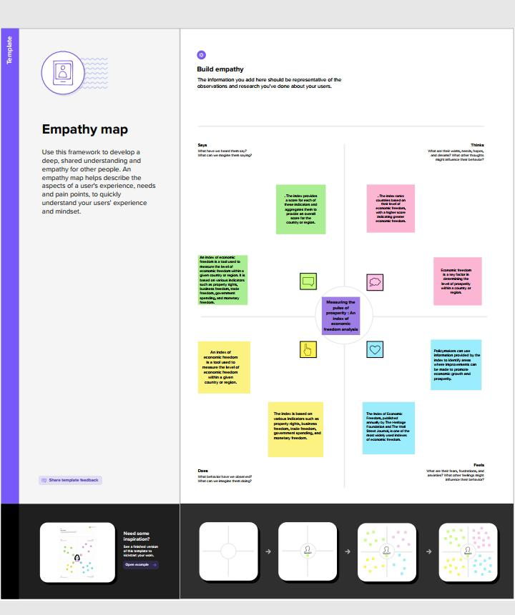

**2.2 Ideation and brainstorming map**

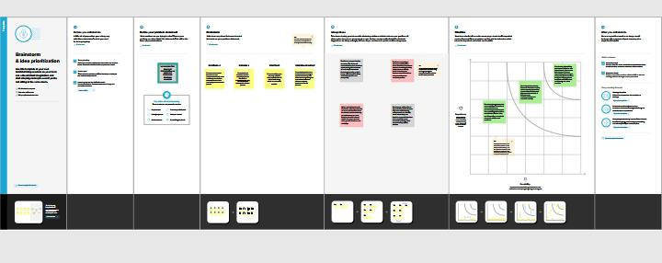

**3.RESULT**

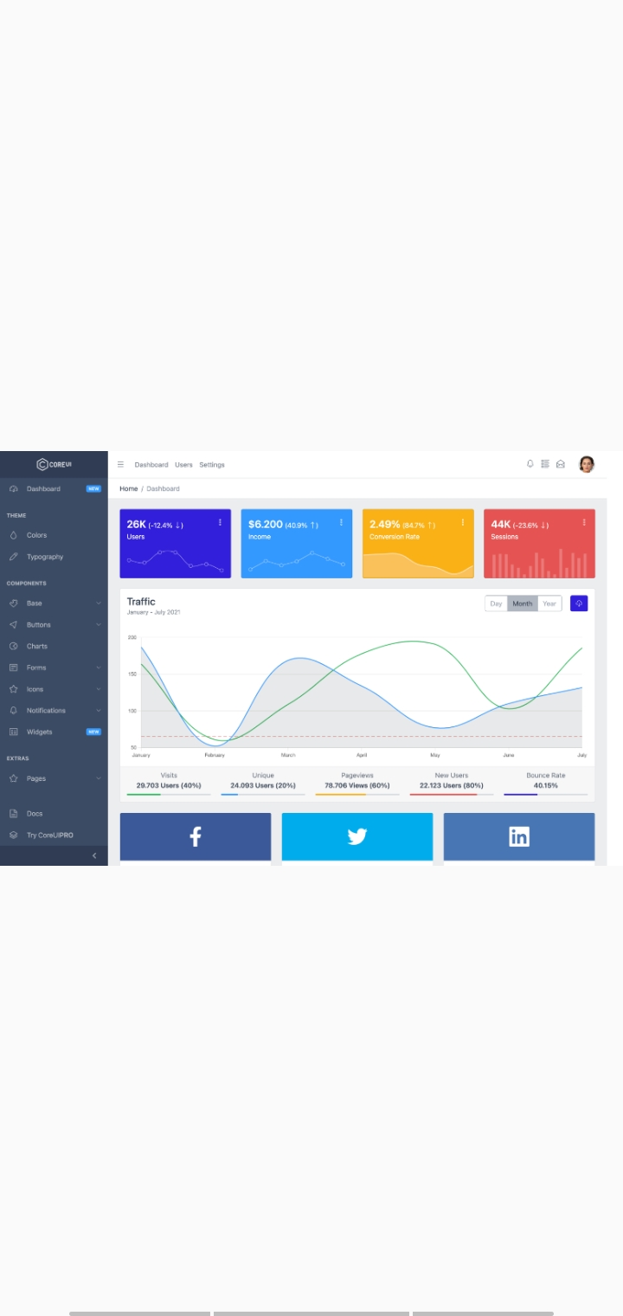

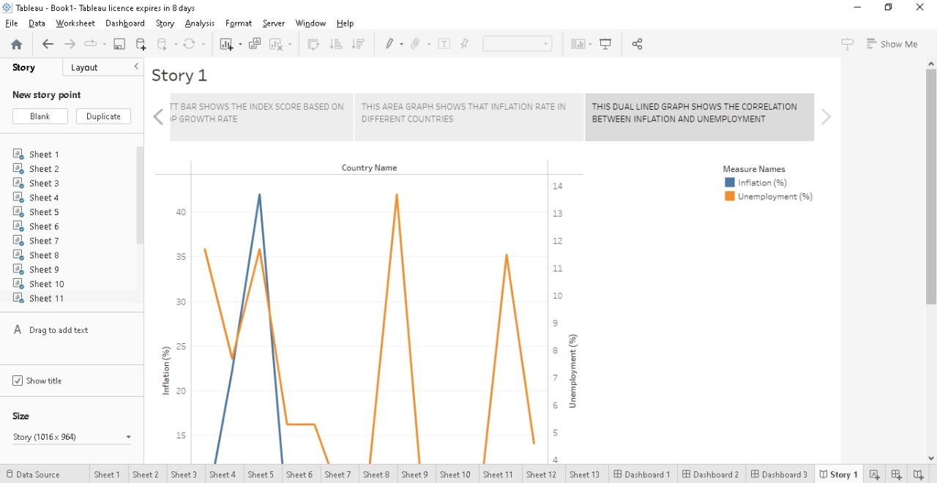

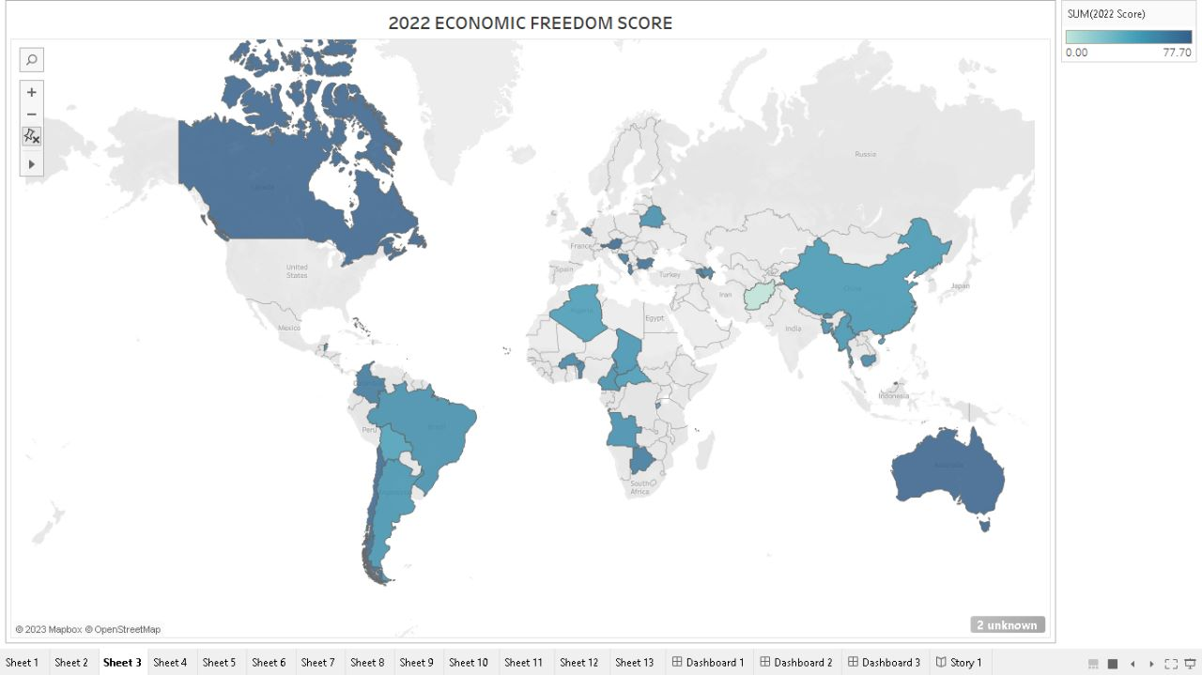

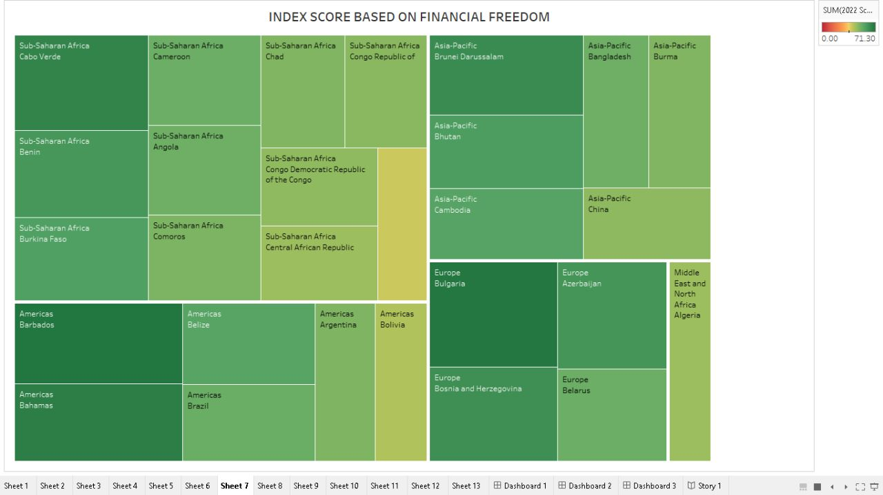

**4.ADVANTAGES AND DISADVANTAGES**

Advantages of measuring the pulse of prosperity through an index of economic freedom analysis include:

1. Objective measurement: An index of economic freedom provides an objective way to measure economic conditions and identify areas for improvement.
2. Cross-country comparisons: An index of economic freedom enables cross-country comparisons, allowing policymakers and investors to identify countries that are more or less conducive to business and investment.
3. Predictive power: Research has shown that countries with higher levels of economic freedom tend to experience higher levels of economic growth and prosperity, indicating that an index of economic freedom can be a useful predictor of economic outcomes.
4. Policy recommendations: An index of economic freedom can help policymakers identify areas where reforms are needed, such as reducing government regulation or improving property rights protections.
5. However, there are also some disadvantages of measuring the pulse of prosperity through an index of economic freedom analysis, including: Limited scope: An index of economic freedom may not capture all factors that contribute to economic growth and prosperity, such as social and environmental factors.
6. Subjective weighting: Different researchers may place different weights on different indicators or factors, which can result in different rankings of countries.
7. Causality issues: While research has shown a correlation between economic freedom and economic growth, it is not always clear whether greater economic freedom causes economic growth, or whether economic growth leads to greater economic freedom.
8. Potential for manipulation: Countries may try to manipulate their scores on an index of economic freedom by changing their policies in order to improve their rankings, rather than implementing policies that actually promote economic growth and prosperity.

In summary, while an index of economic freedom can provide useful insights into economic conditions and policy recommendations, it is important to be aware of its limitations and potential biases.

**APPLICATIONS**

Limited scope: An index of economic freedom may not capture all factors that contribute to economic growth and prosperity, such as social and environmental factors.

Subjective weighting: Different researchers may place different weights on different indicators or factors, which can result in different rankings of countries.

Causality issues: While research has shown a correlation between economic freedom and economic growth, it is not always clear whether greater economic freedom causes economic growth, or whether economic growth leads to greater economic freedom.

Potential for manipulation: Countries may try to manipulate their scores on an index of economic freedom by changing their policies in order to improve their rankings, rather than implementing policies that actually promote economic growth and prosperity**.**

In summary, while an index of economic freedom can provide useful insights into economic conditions and policy recommendations, it is important to be aware of its limitations and potential biases.

6**.CONCLUSION**

In conclusion, measuring the pulse of prosperity through an index of economic freedom analysis is an important tool for policymakers, investors, and researchers to assess the economic conditions of countries or regions. The index provides a quantifiable measure of economic freedom, which is an essential component of economic growth and prosperity. The advantages of using an index of economic freedom include objective measurement, cross-country comparisons, predictive power, and policy recommendations. However, there are also some disadvantages to consider, such as limited scope, subjective weighting, causality issues, and potential for manipulation.

Despite these limitations, measuring the pulse of prosperity through an index of economic freedom analysis has several practical applications, including policymaking, international trade, investment decisions, economic research, and education. By using this tool, policymakers and investors can make informed decisions about economic policies and investments, and researchers can better understand the factors that drive economic growth and prosperity. Overall, the index of economic freedom is a valuable tool for promoting economic freedom and prosperity, and for improving the economic conditions of countries and regions around the world.

**7.FUTURE SCOPE**

There is a significant future scope for the topic of measuring the pulse of prosperity through an index of economic freedom analysis. As the global economy becomes more interconnected, measuring and promoting economic freedom will continue to be a critical issue for policymakers, investors, and researchers.

Some potential future areas of research and development include:

1. Expanding the scope of the index: The current index of economic freedom focuses primarily on the business environment and economic policies. However, future research could expand the scope to include social and political freedoms, such as freedom of speech, association, and assembly, and how they relate to economic growth and prosperity.
2. Addressing causality issues: While the index of economic freedom is a useful tool for identifying the relationship between economic freedom and prosperity, causality issues remain a challenge. Future research could focus on addressing these issues and developing better causal models.
3. Incorporating new data sources: With the increasing availability of big data and artificial intelligence technologies, future iterations of the index of economic freedom could incorporate new data sources, such as social media analytics, satellite imagery, and mobile phone data.
4. Developing regional or sector-specific indices: The current index of economic freedom covers a broad range of economic policies and sectors. However, future research could develop more specific indices that focus on particular regions or sectors, such as the technology industry or emerging markets.

Overall, the future scope for the topic of measuring the pulse of prosperity through an index of economic freedom analysis is vast. By continuing to refine and improve this tool, policymakers, investors, and researchers can better understand the complex relationship between economic freedom and prosperity and work towards creating a more prosperous and equitable global economy.

**8.APPENDIX**

<!DOCTYPE html>

<!--

* CoreUI - Free Bootstrap Admin Template

* @version v4.2.2

* @link https://coreui.io

* Copyright (c) 2022 creativeLabs Łukasz Holeczek

* Licensed under MIT (https://coreui.io/license)

-->

<!-- Breadcrumb-->

<html lang="en">

  <head>

    <base href="./">

    <meta charset="utf-8">

    <meta http-equiv="X-UA-Compatible" content="IE=edge">

    <meta name="viewport" content="width=device-width, initial-scale=1.0, shrink-to-fit=no">

    <meta name="description" content="CoreUI - Open Source Bootstrap Admin Template">

    <meta name="author" content="Łukasz Holeczek">

    <meta name="keyword" content="Bootstrap,Admin,Template,Open,Source,jQuery,CSS,HTML,RWD,Dashboard">

    <title>CoreUI Free Bootstrap Admin Template</title>

    <link rel="apple-touch-icon" sizes="57x57" href="assets/favicon/apple-icon-57x57.png">

    <link rel="apple-touch-icon" sizes="60x60" href="assets/favicon/apple-icon-60x60.png">

    <link rel="apple-touch-icon" sizes="72x72" href="assets/favicon/apple-icon-72x72.png">

    <link rel="apple-touch-icon" sizes="76x76" href="assets/favicon/apple-icon-76x76.png">

    <link rel="apple-touch-icon" sizes="114x114" href="assets/favicon/apple-icon-114x114.png">

    <link rel="apple-touch-icon" sizes="120x120" href="assets/favicon/apple-icon-120x120.png">

    <link rel="apple-touch-icon" sizes="144x144" href="assets/favicon/apple-icon-144x144.png">

    <link rel="apple-touch-icon" sizes="152x152" href="assets/favicon/apple-icon-152x152.png">

    <link rel="apple-touch-icon" sizes="180x180" href="assets/favicon/apple-icon-180x180.png">

    <link rel="icon" type="image/png" sizes="192x192" href="assets/favicon/android-icon-192x192.png">

    <link rel="icon" type="image/png" sizes="32x32" href="assets/favicon/favicon-32x32.png">

    <link rel="icon" type="image/png" sizes="96x96" href="assets/favicon/favicon-96x96.png">

    <link rel="icon" type="image/png" sizes="16x16" href="assets/favicon/favicon-16x16.png">

    <link rel="manifest" href="assets/favicon/manifest.json">

    <meta name="msapplication-TileColor" content="#ffffff">

    <meta name="msapplication-TileImage" content="assets/favicon/ms-icon-144x144.png">

    <meta name="theme-color" content="#ffffff">

    <!-- Vendors styles-->

    <link rel="stylesheet" href="vendors/simplebar/css/simplebar.css">

    <link rel="stylesheet" href="css/vendors/simplebar.css">

    <!-- Main styles for this application-->

    <link href="css/style.css" rel="stylesheet">

    <!-- We use those styles to show code examples, you should remove them in your application.-->

    <link rel="stylesheet" href="https://cdn.jsdelivr.net/npm/prismjs@1.23.0/themes/prism.css">

    <link href="css/examples.css" rel="stylesheet">

    <!-- Global site tag (gtag.js) - Google Analytics-->

    <script async="" src="https://www.googletagmanager.com/gtag/js?id=UA-118965717-3"></script>

    <script>

      window.dataLayer = window.dataLayer || [];

      function gtag() {

        dataLayer.push(arguments);

      }

      gtag('js', new Date());

      // Shared ID

      gtag('config', 'UA-118965717-3');

      // Bootstrap ID

      gtag('config', 'UA-118965717-5');

    </script>

    <link href="vendors/@coreui/chartjs/css/coreui-chartjs.css" rel="stylesheet">

    <link rel="stylesheet" href="https://cdnjs.cloudflare.com/ajax/libs/font-awesome/6.4.0/css/all.min.css" integrity="sha512-iecdLmaskl7CVkqkXNQ/ZH/XLlvWZOJyj7Yy7tcenmpD1ypASozpmT/E0iPtmFIB46ZmdtAc9eNBvH0H/ZpiBw==" crossorigin="anonymous" referrerpolicy="no-referrer" />

  </head>

  <body>

    <div class="sidebar sidebar-dark sidebar-fixed" id="sidebar">

      <div class="sidebar-brand d-none d-md-flex">

        <div>

          CODE UI

        </div>

        <svg class="sidebar-brand-narrow" width="46" height="46" alt="CoreUI Logo">

          <use xlink:href="assets/brand/coreui.svg#signet"></use>

        </svg>

      </div>

      <ul class="sidebar-nav" data-coreui="navigation" data-simplebar="">

        <li class="nav-item"><a class="nav-link" href="index.html">

             &nbsp; <i class="fa fa-tachometer" aria-hidden="true"></i>

            </svg> Dashboard<span class="badge badge-sm bg-info ms-auto">NEW</span></a></li>

        <li class="nav-title">Components</li>

        <li class="nav-item"><a class="nav-link" href="second.html">

          <i class="fa fa-book" aria-hidden="true"></i> &nbsp; Story</a></li>

      </ul>

      <button class="sidebar-toggler" type="button" data-coreui-toggle="unfoldable"></button>

    </div>

    <div class="wrapper d-flex flex-column min-vh-100 bg-light">

      <header class="header header-sticky mb-4">

        <div class="container-fluid">

          <button class="header-toggler px-md-0 me-md-3" type="button" onclick="coreui.Sidebar.getInstance(document.querySelector('#sidebar')).toggle()">

            <!-- <svg class="icon icon-lg">

              <use xlink:href="vendors/@coreui/icons/svg/three-horizontal-lines-icon"></use>

            </svg> -->

            <i class="fa fa-bars" aria-hidden="true"></i>

          </button><a class="header-brand d-md-none" href="#">

            <svg width="118" height="46" alt="CoreUI Logo">

              <use xlink:href="assets/brand/coreui.svg#full"></use>

            </svg></a>

          <ul class="header-nav d-none d-md-flex">

            <li class="nav-item"><a class="nav-link" href="#">Index of Economic Freedom Analysis</a></li>

          </ul>

          <ul class="header-nav ms-auto">

            <li class="nav-item"><a class="nav-link" href="#">

                <svg class="icon icon-lg">

                  <use xlink:href="vendors/@coreui/icons/svg/free.svg#cil-bell"></use>

                </svg></a></li>

            <li class="nav-item"><a class="nav-link" href="#">

                <svg class="icon icon-lg">

                  <use xlink:href="vendors/@coreui/icons/svg/free.svg#cil-list-rich"></use>

                </svg></a></li>

            <li class="nav-item"><a class="nav-link" href="#">

                <svg class="icon icon-lg">

                  <use xlink:href="vendors/@coreui/icons/svg/free.svg#cil-envelope-open"></use>

                </svg></a></li>

          </ul>

            </li>

          </ul>

        </div>

        <div class="header-divider"></div>

        <div class="container-fluid">

          <nav aria-label="breadcrumb">

            <ol class="breadcrumb my-0 ms-2">

              <li class="breadcrumb-item">

                <!-- if breadcrumb is single--><span>Home</span>

              </li>

              <li class="breadcrumb-item active"><span>Dashboard</span></li>

            </ol>

          </nav>

        </div>

      </header>

      <div class="body flex-grow-1 px-3">

        <div class="container-lg">

          <div class="row">

            <div class="col-sm-6 col-lg-3">

              <div class="card mb-4 text-white bg-primary">

                <div class="card-body pb-0 d-flex justify-content-between align-items-start">

                  <div>

                    <div class="fs-4 fw-semibold">Singapore <span class="fs-6 fw-normal">(-12.4%)

                        <svg class="icon">

                          <use xlink:href="vendors/@coreui/icons/svg/free.svg#cil-arrow-bottom"></use>

                        </svg></span></div>

                      </br>

                      <div>is ranked first in the index</div>

                  </div>

                  <div class="dropdown">

                    <button class="btn btn-transparent text-white p-0" type="button" data-coreui-toggle="dropdown" aria-haspopup="true" aria-expanded="false">

                      <svg class="icon">

                        <use xlink:href="vendors/@coreui/icons/svg/free.svg#cil-options"></use>

                      </svg>

                      <div class="c-chart-wrapper mt-3 mx-3" style="height:70px;">

                        <canvas class="chart" id="card-chart1" height="70"></canvas>

                    </button>

                    <div class="dropdown-menu dropdown-menu-end"><a class="dropdown-item" href="#">Action</a><a class="dropdown-item" href="#">Another action</a><a class="dropdown-item" href="#">Something else here</a></div>

                  </div>

                </div>

              </div>

            </div>

            <!-- /.col-->

            <div class="col-sm-6 col-lg-3">

              <div class="card mb-4 text-white bg-info">

                <div class="card-body pb-0 d-flex justify-content-between align-items-start">

                  <div>

                    <div class="fs-4 fw-semibold">2,355.1% <span class="fs-6 fw-normal">(40.9%)

                        <svg class="icon">

                          <use xlink:href="vendors/@coreui/icons/svg/free.svg#cil-arrow-top"></use>

                        </svg></span></div>

                    <div>Venezula has the highest inflation Rate</div>

                  </div>

                  <div class="dropdown">

                    <button class="btn btn-transparent text-white p-0" type="button" data-coreui-toggle="dropdown" aria-haspopup="true" aria-expanded="false">

                      <svg class="icon">

                        <use xlink:href="vendors/@coreui/icons/svg/free.svg#cil-options"></use>

                      </svg>

                    </button>

                    <div class="dropdown-menu dropdown-menu-end"><a class="dropdown-item" href="#">Action</a><a class="dropdown-item" href="#">Another action</a><a class="dropdown-item" href="#">Something else here</a></div>

                  </div>

                </div>

                <div class="c-chart-wrapper mt-3 mx-3" style="height:70px;">

                  <canvas class="chart" id="card-chart2" height="70"></canvas>

                </div>

              </div>

            </div>

            <!-- /.col-->

            <div class="col-sm-6 col-lg-3">

              <div class="card mb-4 text-white bg-warning">

                <div class="card-body pb-0 d-flex justify-content-between align-items-start">

                  <div>

                    <div class="fs-4 fw-semibold">43.40%<span class="fs-6 fw-normal">(84.7%)

                        <svg class="icon">

                          <use xlink:href="vendors/@coreui/icons/svg/free.svg#cil-arrow-top"></use>

                        </svg></span></div>

                    <div>Guyana has the fastest growing gdp</div>

                  </div>

                  <div class="dropdown">

                    <button class="btn btn-transparent text-white p-0" type="button" data-coreui-toggle="dropdown" aria-haspopup="true" aria-expanded="false">

                      <svg class="icon">

                        <use xlink:href="vendors/@coreui/icons/svg/free.svg#cil-options"></use>

                      </svg>

                    </button>

                    <div class="dropdown-menu dropdown-menu-end"><a class="dropdown-item" href="#">Action</a><a class="dropdown-item" href="#">Another action</a><a class="dropdown-item" href="#">Something else here</a></div>

                  </div>

                </div>

                <div class="c-chart-wrapper mt-3" style="height:70px;">

                  <canvas class="chart" id="card-chart3" height="70"></canvas>

                </div>

              </div>

            </div>

            <!-- /.col-->

            <div class="col-sm-6 col-lg-3">

              <div class="card mb-4 text-white bg-danger">

                <div class="card-body pb-0 d-flex justify-content-between align-items-start">

                  <div>

                    <div class="fs-4 fw-semibold">28.70% <span class="fs-6 fw-normal">(-23.6%)

                        <svg class="icon">

                          <use xlink:href="vendors/@coreui/icons/svg/free.svg#cil-arrow-bottom"></use>

                        </svg></span></div>

                    <div>Has the highest unemployment rate</div>

                  </div>

                  <div class="dropdown">

                    <button class="btn btn-transparent text-white p-0" type="button" data-coreui-toggle="dropdown" aria-haspopup="true" aria-expanded="false">

                      <svg class="icon">

                        <use xlink:href="vendors/@coreui/icons/svg/free.svg#cil-options"></use>

                      </svg>

                    </button>

                    <div class="dropdown-menu dropdown-menu-end"><a class="dropdown-item" href="#">Action</a><a class="dropdown-item" href="#">Another action</a><a class="dropdown-item" href="#">Something else here</a></div>

                  </div>

                </div>

                <div class="c-chart-wrapper mt-3 mx-3" style="height:70px;">

                  <canvas class="chart" id="card-chart4" height="70"></canvas>

                </div>

              </div>

            </div>

            <!-- /.col-->

          </div>

          <!-- /.row-->

          <div class="card mb-4">

            <div class="card-body">

              <div class="d-flex justify-content-between">

                <div class='tableauPlaceholder' id='viz1681738638377' style='position: relative'><noscript><a href='#'><img alt='Dashboard 1 ' src='https:&#47;&#47;public.tableau.com&#47;static&#47;images&#47;Bo&#47;Book1_16815441897210&#47;Dashboard1&#47;1_rss.png' style='border: none' /></a></noscript><object class='tableauViz'  style='display:none;'><param name='host_url' value='https%3A%2F%2Fpublic.tableau.com%2F' /> <param name='embed_code_version' value='3' /> <param name='site_root' value='' /><param name='name' value='Book1_16815441897210&#47;Dashboard1' /><param name='tabs' value='no' /><param name='toolbar' value='yes' /><param name='static_image' value='https:&#47;&#47;public.tableau.com&#47;static&#47;images&#47;Bo&#47;Book1_16815441897210&#47;Dashboard1&#47;1.png' /> <param name='animate_transition' value='yes' /><param name='display_static_image' value='yes' /><param name='display_spinner' value='yes' /><param name='display_overlay' value='yes' /><param name='display_count' value='yes' /><param name='language' value='en-US' /></object></div>                <script type='text/javascript'>                    var divElement = document.getElementById('viz1681738638377');                    var vizElement = divElement.getElementsByTagName('object')[0];                    if ( divElement.offsetWidth > 800 ) { vizElement.style.width='1000px';vizElement.style.height='827px';} else if ( divElement.offsetWidth > 500 ) { vizElement.style.width='1000px';vizElement.style.height='827px';} else { vizElement.style.width='100%';vizElement.style.height='1127px';}                     var scriptElement = document.createElement('script');                    scriptElement.src = 'https://public.tableau.com/javascripts/api/viz_v1.js';                    vizElement.parentNode.insertBefore(scriptElement, vizElement);                </script>

            </div>

            <div>

              <div class="body flex-grow-1 px-3">

                <div class="container-lg">

                  <div class="row">

                    <div class="col-sm-6 col-lg-3">

                      <div class="card mb-4 text-white bg-primary">

                        <div class="card-body pb-0 d-flex justify-content-between align-items-start">

                          <div>

                            <div class="fs-4 fw-semibold">India's GDP growth rate?<span class="fs-6 fw-normal">

                                <svg class="icon">

                                  <use xlink:href="vendors/@coreui/icons/svg/free.svg#cil-arrow-bottom"></use>

                                </svg></span></div>

                              </br>

                              <div>INDIA'S 5 YEAR GDP GROWTH RATE IS 3.50%</div>

                          </div>

                          <div class="dropdown">

                            <button class="btn btn-transparent text-white p-0" type="button" data-coreui-toggle="dropdown" aria-haspopup="true" aria-expanded="false">

                              <svg class="icon">

                                <use xlink:href="vendors/@coreui/icons/svg/free.svg#cil-options"></use>

                              </svg>

                            </button>

                            <div class="dropdown-menu dropdown-menu-end"><a class="dropdown-item" href="#">Action</a><a class="dropdown-item" href="#">Another action</a><a class="dropdown-item" href="#">Something else here</a></div>

                          </div>

                        </div>

                      </div>

                    </div>

                    <!-- /.col-->

                    <div class="col-sm-6 col-lg-3">

                      <div class="card mb-4 text-white bg-info">

                        <div class="card-body pb-0 d-flex justify-content-between align-items-start">

                          <div>

                            <div class="fs-4 fw-semibold">INDIA'S RANKING ON THE INDEX<span class="fs-6 fw-normal">

                                <svg class="icon">

                                  <use xlink:href="vendors/@coreui/icons/svg/free.svg#cil-arrow-top"></use>

                                </svg></span></div>

                            <div>INDIA IS RANKED 131 ON THE 2022 ECONOMIC FREEDOM INDEX OUT OF 184 COUNTRIES</div>

                          </div>

                          <div class="dropdown">

                            <button class="btn btn-transparent text-white p-0" type="button" data-coreui-toggle="dropdown" aria-haspopup="true" aria-expanded="false">

                              <svg class="icon">

                                <use xlink:href="vendors/@coreui/icons/svg/free.svg#cil-options"></use>

                              </svg>

                            </button>

                            <div class="dropdown-menu dropdown-menu-end"><a class="dropdown-item" href="#">Action</a><a class="dropdown-item" href="#">Another action</a><a class="dropdown-item" href="#">Something else here</a></div>

                          </div>

                        </div>

                        <div class="c-chart-wrapper mt-3 mx-3" style="height:70px;">

                          <canvas class="chart" id="card-chart2" height="70"></canvas>

                        </div>

                      </div>

                    </div>

                    <!-- /.col-->

                    <div class="col-sm-6 col-lg-3">

                      <div class="card mb-4 text-white bg-warning">

                        <div class="card-body pb-0 d-flex justify-content-between align-items-start">

                          <div>

                            <div class="fs-4 fw-semibold">INDIA'S REGION(ASIS) RANK? <span class="fs-6 fw-normal">

                                <svg class="icon">

                                  <use xlink:href="vendors/@coreui/icons/svg/INDIA.png"></use>

                                </svg></span></div>

                            <div>INDIA IS RANKED 27TH IN THE ASIA-PACIFIC REGION ON THE 2022 INDEX OF ECONOMIC FREEDOM</div>

                          </div>

                          <div class="dropdown">

                            <button class="btn btn-transparent text-white p-0" type="button" data-coreui-toggle="dropdown" aria-haspopup="true" aria-expanded="false">

                              <svg class="icon">

                                <use xlink:href="vendors/@coreui/icons/svg/free.svg#cil-options"></use>

                              </svg>

                            </button>

                            <div class="dropdown-menu dropdown-menu-end"><a class="dropdown-item" href="#">Action</a><a class="dropdown-item" href="#">Another action</a><a class="dropdown-item" href="#">Something else here</a></div>

                          </div>

                        </div>

                        <div class="c-chart-wrapper mt-3" style="height:70px;">

                          <canvas class="chart" id="card-chart3" height="70"></canvas>

                        </div>

                      </div>

                      </div>

                    </br>

              <div class='tableauPlaceholder' id='viz1681741405315' style='position: relative'><noscript><a href='#'><img alt='2022 ECONOMIC FREEDOM SCORE ' src='https:&#47;&#47;public.tableau.com&#47;static&#47;images&#47;sh&#47;sheet3_16817411664980&#47;Sheet3&#47;1_rss.png' style='border: none' /></a></noscript><object class='tableauViz'  style='display:none;'><param name='host_url' value='https%3A%2F%2Fpublic.tableau.com%2F' /> <param name='embed_code_version' value='3' /> <param name='site_root' value='' /><param name='name' value='sheet3_16817411664980&#47;Sheet3' /><param name='tabs' value='no' /><param name='toolbar' value='yes' /><param name='static_image' value='https:&#47;&#47;public.tableau.com&#47;static&#47;images&#47;sh&#47;sheet3_16817411664980&#47;Sheet3&#47;1.png' /> <param name='animate_transition' value='yes' /><param name='display_static_image' value='yes' /><param name='display_spinner' value='yes' /><param name='display_overlay' value='yes' /><param name='display_count' value='yes' /><param name='language' value='en-US' /></object></div>                <script type='text/javascript'>                    var divElement = document.getElementById('viz1681741405315');                    var vizElement = divElement.getElementsByTagName('object')[0];                    vizElement.style.width='100%';vizElement.style.height=(divElement.offsetWidth*0.75)+'px';                    var scriptElement = document.createElement('script');                    scriptElement.src = 'https://public.tableau.com/javascripts/api/viz_v1.js';                    vizElement.parentNode.insertBefore(scriptElement, vizElement);    align="center"             </script>

          </div>

        </div>

      </div>

      <footer class="footer">

        <div><a href="https://coreui.io">CoreUI </a><a href="https://coreui.io">Bootstrap Admin Template</a> © 2022 creativeLabs.</div>

        <div class="ms-auto">Powered by&nbsp;<a href="https://coreui.io/docs/">CoreUI UI Components</a></div>

      </footer>

    </div>

    <!-- CoreUI and necessary plugins-->

    <script src="vendors/@coreui/coreui/js/coreui.bundle.min.js"></script>

    <script src="vendors/simplebar/js/simplebar.min.js"></script>

    <!-- Plugins and scripts required by this view-->

    <script src="vendors/chart.js/js/chart.min.js"></script>

    <script src="vendors/@coreui/chartjs/js/coreui-chartjs.js"></script>

    <script src="vendors/@coreui/utils/js/coreui-utils.js"></script>

    <script src="js/main.js"></script>

    <script>

    </script>

  </body>

</html>